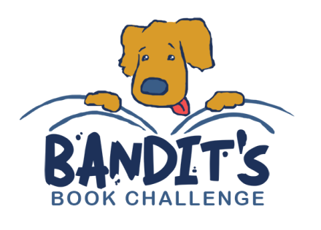

2017-2018 Bandit’s Book Challenge

Bandit’s Book Challenge Record Form
Once your child has read 10 books, please return to
your child’s teacher by April 16,2018. Thank you.

________________________________ _______________________
Student’s Name* - Please Print School Name
*Name will be printed on certificate as it appears above.

___________________________________________________
Student’s Address- Please Print complete address

Title of Book Title of Book

- 6.
- 7.
- 8.
- 9.
- 10.

_______________________________________
Signature of Parent or Guardian

