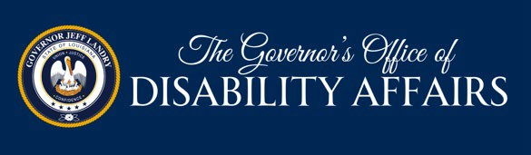

2026 Inclusive Art Contest
Theme: “ONE LOUISIANA”

In the spirit of the 36th year of the Americans with Disabilities Act (ADA) and to bring greater awareness to the importance of inclusion in today’s society, the Governor's Office of Disability Affairs (GODA) invites you to participate in the 2026 Inclusive Art Contest. GODA will accept entries that illustrate or describe ideas related to the law which ensures individuals with disabilities have the same rights and opportunities as everyone else by requiring reasonable accommodations and accessibility. Contestants are encouraged to use original art to share their vision, experiences and talents, and tributes to disability advocates to demonstrate this year's theme. A medal and special recognition will be presented to the winners Wednesday, December 2, 2026. Winning entries will be publicly displayed.
Contest Rules
- Open to ALL residents of Louisiana of any age.
- No group entry will be accepted.
- All entries must be received by Monday, November 2, 2026.
- Winning artwork may not be returned.
- Artwork not selected as winners may be picked up at the GODA office in Baton Rouge. GODA will not be responsible for any entry not picked up by December 31, 2026.
- By submitting your entry, you give GODA permission to use your entry in support of the contest.
- The registration form must be typed or printed legibly in ink, signed, and attached to the back of your entry. (Please do not staple the registration form to your artwork.)
- GODA will not pay for postage due on parcels. Submissions must be mailed with adequate postage.
Criteria for Art Entries
- All entries must be original and framed or ready to hang.
- Submissions must be NO LARGER than 16 x 20 inches. Any suitable materials or computer-generated design may be utilized.
- Entries must be packaged so that they are easy to carry, transport, and display.
- The use of generative AI content is not permitted.
Criteria for Written Entries
- All entries must be less than 300 words.
- Entries can be poems, lyrics, essays, speeches, and short stories.
- The entry must be typed or printed legibly.
- The use of generative AI content is not permitted.

Contestants are encouraged to use art to share their vision, experiences, and talents to demonstrate “One Louisiana.” A medal and special recognition will be presented to the winners Wednesday, December 2, 2026. All Contestants are encouraged to conduct research and educate themselves of the importance of accessibility and inclusion.

2026 GODA Inclusive Art Contest

Theme: “ONE LOUISIANA”

(Please Print)
Registration Information
Name:
Address:
City, LA: Zip
Phone Number:
Email:
Age/Adult
Grade:
(if applicable)

If your Visual or Written Art is submitted through your participation in a school or organization, please list the information here:

School/Organization
Teacher/Leader
Address:
City, LA: Zip
Phone Number:
Email:

Contestant’s signature:
Parent signature
(if applicable)
I hereby grant the Governor's Office of Disability Affairs permission to use my likeness in photography in any and all of its publications, including website entries, without payment or any other consideration. I also understand all rules and regulations relative to this contest.

PLEASE ENSURE ALL SUBMISSIONS ARE COMPLETE and MAIL TO:

Office of the Governor Attn: GODA
1051 N 3rd Street, Suite 129 Baton Rouge, LA 70802
Please provide a brief description of your work.

